**1) Explain what is LINQ? Why is it required?**

Language Integrated Query or LINQ is the collection of standard query operators which provides query facilities into.NET framework language like C#, VB.NET. LINQ is required as it bridges the gap between the world of data and world of objects.

**2) What are the types of LINQ?**

* LINQ to Objects
* LINQ to [XML](https://career.guru99.com/xml-interview-questions/)
* LINQ to Dataset
* LINQ to SQL
* LINQ to Entities

**3) Explain how LINQ is useful than Stored Procedures?**

* **Debugging:** It is difficult to debug a stored procedure but as LINQ is part of [.NET](https://career.guru99.com/net-technology-interview-questions/), visual studios debugger can be used to debug the queries
* **Deployment:** For stored procedure, additional script should be provided but with LINQ everything gets compiled into single DLL hence deployment becomes easy
* **Type Safety:** LINQ is type safe, so queries errors are type checked at compile time

**4) List out the three main components of LINQ? Explain what is the extension of the file, when LINQ to SQL is used?**

Three main components of LINQ are

* Standard Query Operators
* Language Extensions
* LINQ Providers

The extension of the file used is .dbml

**5) Define what is Where clause and Let clause?**

* **Where clause**: It allows adding some conditional filters to the query.
* **Let clause**: It allows defining a variable and assigning it a value calculated from the data values.

**6) Explain why SELECT clause comes after FROM clause in LINQ?**

With other programming language and C#, LINQ is used, it requires all the variables to be declared first. “FROM” clause of LINQ query defines the range or conditions to select records. So, FROM clause must appear before SELECT in LINQ.

**7) Explain what is the use of System.XML.Xlinq.dll?**

**System.Data.Dlinq.dll** provides the functionality to work with LINQ to SQL

**8) Explain what is lambda expressions in LINQ?**

Lambda expression is referred as a unique function use to form delegates or expression tree types, where right side is the output and left side is the input to the method. For writing LINQ queries particularly, Lambda expression is used.

**9) Explain how LINQ with databases can be used?**

LINQ supports XML, SQL, Dataset and Objects. Through LINQ to objects or LINQ to Datasets one can use LINQ with other databases. The objects and datasets take care of database particular operations, and LINQ only needs to deal with those objects and not the database operations directly.

**10) Explain what is the difference between Skip() and SkipWhile() extension method?**

* **Skip():** It will take an integer argument and from the given IEnumerable it skips the top n numbers
* **SkipWhile ():** It will continue to skip the elements as far as the input condition is true. It will return all remaining elements if the condition is false

**11) In LINQ how will you find the index of the element using where () with Lambda Expressions?**

In order to find the index of the element using where () with the lambda expression Where ( ( i, ix ) => i == ix);

**12) Explain how you can assign a lambda expression to a delegate?**

To assign a lambda expression to a delegate

Delegate int del (int i);

Del myDelegate=x=>x*x;

Intj = myDelegate (4); //j=16

**13) Explain what is the difference between Statement Lambda and Expression Lambda?**

* Expression Lambdas are extensively used in the construction of Expression Trees
* To create expression trees statement lambdas cannot be used

**14) Mention what is the role of DataContext classes in LINQ?**

DataContext class acts as a bridge between [SQL Server](https://www.guru99.com/sql-server-questions.html) database and the LINQ to SQL. For accessing the database and also for changing the data in the database, it contains connections string and the functions.

**15) Explain what are LINQ query expressions?**

Query expression is nothing but an LINQ query. It is a combination of query clauses that identifies the data sources for a query. It contains information for sorting, filtering, grouping or joining to apply to the source data. It determines what information should be retrieved from the data source.CV.

**16) Explain what are compiled queries?**

In compiled LINQ queries, the plan is cached in a static class and static class is a global cache. Rather than preparing the query plan from scratch, LINQ prepares plan using stating class object.

**17) Explain how standard query operators useful in LINQ?**

Standard Query Operators useful in LINQ are

* Get a total count of elements in the collection
* Order the results of a collection
* Grouping
* Computing average
* Joining two collections based on matching keys
* Filter the results

**18) Explain what is the purpose of LINQ providers in LINQ?**

LINQ providers are set of classes that take an LINQ query which generates method that executes an equivalent query against a particular data source.

**19) Explain how you can retrieve a single row with LINQ?**

To retrieve a single row with LINQ we need

Public User GetUser (string userName)

{

DBNameDataContext myDB = new DBNameDataContext ( ) ;

User user = myDB. Users. Single ( u, u.UserName => userName );

Return user;

}

**20) LINQ query is executed in which statement?**

In VB, an LINQ query is executed in the For Each Statement, and in the foreach statement for C#.

**21) Explain what is “LINQ to Objects”?**

When LINQ queries any IEnumerable(Of T) collection or IEnumerable directly without the use of an intermediate LINQ provider or API such as LINQ to SQL or LINQ to [XML](https://career.guru99.com/xml-interview-questions/) is referred as “LINQ to Objects.”

**22) Explain how you can differentiate between Conversion Operator “ToDictionary” and “IEnumerable” of LINQ?**

To solve the conversion type problems “IEnumerable” and “ToDictionary” conversion operator are used.

“ToDictionary” conversion operator is the instance of Dictionary (k, T). The “keySelector” predicate recognizes the key of each item, while “elementSelector”, is used to extract each single item, if it is given.

Extension method on “IEnumerable” is.AsEnumerable. AsEnumerable simply returns the source sequence as an object of type IEnumerable <T>.

**1. What is LINQ?**

Language Integrated Query is known by the acronym LINQ. It is a module for the.NET framework that links native data querying features to the.net Language. It provides simple data access from in-memory objects, databases, XML documents, and many more sources.

**2. What are the benefits of LINQ in Dataset?**

LINQ has the following advantages:

* LINQ is mainly used to extract complicated queries from datasets.
* Values from two separate data sets are combined using LINQ.
* Additionally, a unique value from the data collection is fetched using it.
* Compared to a SQL query, LINQ offers a more precise method of dataset querying.
* LINQ provides more features than ADO.NET.

**3. What is the LINQ architecture?**

LINQ has a three-layered architecture. The language extensions are located in the top layer, and the data sources are located in the bottom layer. The objects used as the data sources often implement the general IEnumerable or IQueryable interfaces.

Other than the fundamental LINQ query and data sources, an additional element is presently called the LINQ provider. The purpose of a LINQ provider is to translate a LINQ query into a format that the available data sources can understand.

**4. What are the different forms of writing LINQ query syntax?**

A LINQ query to data sources can be written in one of two ways.

1. Expression syntax or query syntax
2. Method Extension Syntax or Method Syntax

**5. Explain the Query syntax?**

The query syntax is comparable to the database's Structured Query Language. The C# or VB code contains a description of it.

**Syntax:**

from <range variable> in <IEnumerable<T> or IQueryable<T> Collection>

<specific Query Operators> <lambda expression>

<select or groupBy operator> <result formation>

 The key components of query syntax are listed below.

* It begins with the keyword FROM and concludes with the keyword SELECT or GROUP BY.
* The syntax resembles that of SQL (Structured Query Language).
* To create the desired output, it employs a variety of operators, including joining, grouping, sorting, and filtering operators.
* It uses implicitly typed variables to store the LINQ query's outcome.

**6. What is LINQ method syntax?**

Some additional Enumerable or Queryable static class methods are used in the LINQ method syntax. Because it makes it possible to invoke several extension methods, LINQ Method Syntax is also known as fluent syntax. The LINQ query result can be stored in an implicitly typed variable.

**Syntax:**

// Collection of String

IList<string> stringList = new List<string> () {

                                    "Python Developer",

           ".Net Developer",

           "Web Developer",

           "Full Stack Developer" ,

           "Python"};

// Syntax of LINQ Query

var result = stringList.

Where(s => s.Contains("Coding"));

**7. What is LINQ to XML?**

The built-in document reform features of the DOM (Document Object Model) are provided by LINQ to XML, which also supports LINQ Queries. It allows us to edit an XML document's query, navigate, and save changes. It enables us to create questions to search through and retrieve a set of elements and attributes. It resembles XPath and XQuery quite a little.

**8. Describe LINQ to SQL.**

One of the ADO.NET technologies is LINQ to SQL. The relational data is managed by it as an object. The language-integrated queries in the object are converted to SQL via LINQ and sent to the database for processing. When the database responds, LINQ to SQL converts the responses back to objects.

**9. What are the different types of LINQ?**

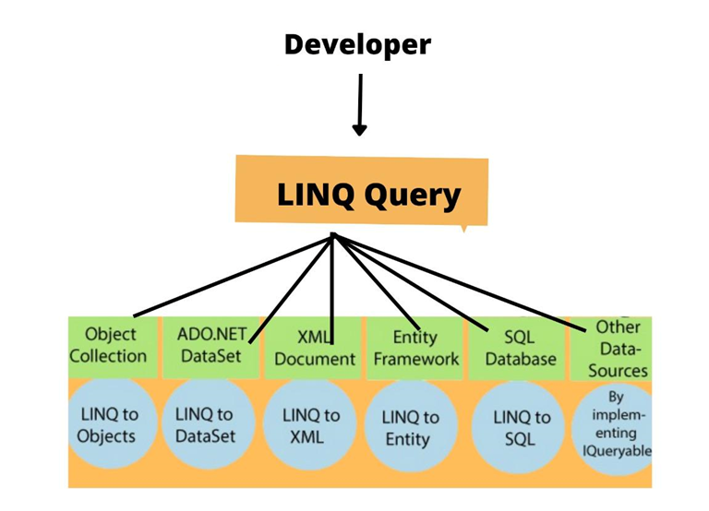

It is important to know the various types of LINQ used as it is often asked in LINQ interview questions. Following is a list of the various types of LINQ

* LINQ to Objects
* LINQ to Entities
* LINQ to DataSet
* LINQ to SQL (DLINQ)
* LINQ to XML(XLINQ).

In addition to the types of LINQ mentioned above, there is also one called PLINQ, which is Microsoft's parallel LINQ.

**10. Explain is a LinqDataSource control.**

LinqDataSource is a vital dataset component if you use LINQ in an [ASP.NET](https://www.naukri.com/code360/library/asp-net-introduction-and-features) webpage. It controls, retrieves, and alters data and sets the properties in the markup text. Additionally, it can explicitly tie data sources to other [**ASP.NET**](https://www.naukri.com/code360/library/asp-net) controls on a page. It is comparable to ObjectDataSource controls, and SQL Datasource controls in this way.

**11. What makes LINQ and stored procedures different?**

The following list highlights some key distinctions between LINQ and stored procedures often asked in the LINQ interviews:

* Because stored procedures adhere to a correct (Expected) execution plan.
* Unlike a stored procedure, a SQL query is simpler to avoid runtime mistakes.
* In contrast to stored procedures, which do not support debugging, LINQ does.
* In comparison to stored procedures, LINQ supports a variety of databases.
* LINQ-based solutions are easier to install than stored procedure-based solutions.

**12. What is API in LINQ?**

Classes that implement the IEnumerable or IQueryable interfaces can implement LINQ queries. The System.Linq namespace  System provides several classes. Linq namespace that offers the interfaces needed for LINQ queries.

LINQ queries use some extension methods for classes that implement the IEnumerable or IQueryable interfaces.

**13. In LINQ, what is an Expression Tree?**

Expression Tree construction makes extensive use of lambda expressions. Each node serves as an impression in an Expression Tree, which displays code in a tree-like structure. Expression trees may be compiled into code and executed.

Through the API, the.NET framework's Expression class is utilized to generate expression trees. Assignment and a few control flow expressions, including conditional blocks, loops, and try-catch blocks, are also supported by the Expression Trees API. We may produce expression trees that are more intricate by using the API as opposed to lambda expressions.

**14. What is LINQ Lambda expression?**

LINQ refers to a function with no name as a lambda expression. The syntax is expanded by being made concise and precise. Despite not being as readable as a LINQ query, it is just as significant. Lambda expression has a constrained range. It is not reusable.

Syntax:

(Input Variable) => Method Expression

The type is chosen during compilation via a lambda expression. We enclose a parameter as an input on the left side of the expression with a bracket (). Any name may be used for the parameter. To transmit a parameter from the left to the right side, use the equal to (=) symbol before the parameter name, followed by the greater one (>) sign. The needed procedure is carried out on the right side utilizing the input password given by the left side parameter. Lambda expression is the name of the full syntax.

**15. What is the fundamental syntax for a LINQ query in Visual Basic?**

The basic LINQ query syntax in Visual Basic is started with the From keyword and finishes with the Select or Group By keyword. Other keywords, such as Where, Order By, Order By Descending, etc., can be used to carry out extra tasks, such as data filtering or data generation in a particular order.

**16. What is the fundamental syntax for a LINQ query in C#?**

The fundamental syntax in C# begins with the from keyword and ends with the Select or Group By keyword. Another clause, such as Where, Order By, Order By Descending, etc., can be used. For carrying out tasks like data filtering or data generation in a particular order.

**17. What does the term "DataContext class" mean? How does it connect to LINQ?**

The DataContext class serves as a passing point for the LINQ to SQL framework. It serves as the basis for every access mapped over a database connection.

A Data context can be made easily and effectively. Empty DataContext classes prepared for configuration are represented as a blank design surface after adding LINQ to SQL classes. The DataContext class contains details on database connection methods. It also alters the data in the database. DataContext classes are given access to the connection data provided by the first item for configuration.

**18. Why does the FROM clause occur before the SELECT clause in LINQ?**

When LINQ is used with other programming languages besides C#, all variables must first be defined. The LINQ query's "FROM" clause specifies the parameters or criteria for choosing records. Thus, with LINQ, the FROM clause must come before the SELECT.

**19. Explain the PLINQ?**

It is one of the most commonly asked LINQ interview questions. Parallel LINQ is referred to as PLINQ. It is a LINQ to object parallel implementation. Due to its tight ties to the task parallel library, it supports parallel programming. With some queries, it makes it easier to use many processors automatically. PLINQ can speed up LINQ to Objects queries by effectively utilizing all of the host computer's cores.

**20. What are the standard LINQ query operators?**

LINQ query operators are often an interviewer’s favorite in the LINQ interview questions, so it is important to prepare them thoroughly

The methods that make up the LINQ pattern are the standard query operators. These methods are used on sequences and objects that implement the IEnumerableT> or the IQueryableT> interfaces. Filtering, projection, sorting, aggregation, and other query features are available through the basic query operators.

There are two groups of LINQ standard query operators. The first group works with IEnumerable<T> type objects, whereas the second group works with IQueryable<T> type objects.

Take a look at the following syntax:

var voter= from v in voterList where v.age>18 select v;

In the example above, the operators where and select are standard query operators. 

**21. List some important Standard Query Operators used in LINQ.**

Another most frequently asked LINQ interview question. Based on their functionality, the LINQ standard query operators can be divided into groups based on their functionality.

|  |  |
| --- | --- |
| **Classification** | **Standard Query Operators** |
| Sorting | OrderBy, ThenBy, Reverse, OrderByDescending, ThenByDescending |
| Filtering | Where, OfType |
| Join | GroupJoin, Join |
| Aggregation | Aggregate, Average, Count, LongCount, Max, Min, Sum |
| Projection | Select, SelectMany |
| Set | Distinct, Except, Intersect, Union |
| Quantifiers | All, Any, Contains |
| Concatenation | Concat |
| Partitioning | Skip, SkipWhile, Take, TakeWhile |
| Conversion | AsEnumerable, AsQueryable, Cast, ToArray, ToDictionary, ToList |
| Equality | SequenceEqual |

**22. What are the primary LINQ components, please? In the case of LINQ to SQL, what is the file extension?**

There are three primary elements to LINQ:

* LINQ Providers
* Language Extensions,
* Standard Query Operators.

When using LINQ to SQL, the file extension is .dbml.

**23. What do Anonymous Types mean? Discuss its limitations.**

An anonymous type is one that the compiler creates at runtime. When constructing the Anonymous compiler, the name is not required, but we may still define the names of the properties and their values. The compiler creates these attributes, and runtime values are assigned to them. In LINQ queries, the anonymous class is helpful. While running queries, it saves the interim result.

Additionally, there are several limitations for Anonymous types:

* Anonymous types cannot implement interfaces.
* No methods can be specified for anonymous types.
* The static members cannot be defined.
* It is required to initialize all defined properties.
* We are limited to defining public fields.

**24. Describe LINQ compiled queries.**

There can be an incident where we need to run a specific query repeatedly. With LINQ, we can build a query and have it always be compiled.

Advantages of Compiled Queries:

* Since these queries don't need to be compiled every time, they execute quickly.
* These queries can be used as often as needed after being created once.
* Even if a query's parameter changes, these queries must be recompiled.

**Example:**

static class MyCompliedQueries {

   public static Func <DataClasses1DataContext, IQueryable <Person>> CompliedQueryForPerson =

       CompiledQuery. Compile((DataClasses1DataContext context) = >from c in context. Persons select c);

}

**25. Give the differences between the extension methods Skip() and SkipWhile().**

|  |  |
| --- | --- |
| **Skip()** | **SkipWhile()** |
| Skip() will accept an integer parameter and skips the first n numbers from the specified IEnumerable. | While the input condition is true, SkipWhile () will keep skipping the components. It will return all of the remaining elements if the condition is false. |

**26. How do LINQ's Single() and First() extension functions vary?**

|  |  |
| --- | --- |
| **Single()** | **First()** |
| is used to return a single specific result from a query or, in the absence of a match, a default value. | It returns any query with more than one element's first value. |
| Used when the desired outcome is exactly one element. | Used when only the first value is required, and several result expectations exist.. |

**27. What distinguishes N-layer architecture from N-tier architecture?**

|  |  |
| --- | --- |
| **N-layer** | **N-tier** |
| The components in various levels may all be housed on the same physical computer (server), but they communicate through well-defined interfaces. | At least three distinct logical components are housed on a different physical server. |
| Layers are explicitly and loosely connected. | In this case, communication between the layers is asynchronous to allow scalability. |

### 1. Define LINQ? Why is it important?

The complete form of “LINQ” is Language Integrated Query. It is the [.NET framework](https://mindmajix.com/what-is-net-framework) component that links initial data querying abilities to the .NET languages. LINQ provides simple data access from in-memory databases, objects, XML documents, etc.

### 2. What are the kinds of LINQ?

Following are the different kinds of LINQ:

* LINQ to XML
* LINQ to Objects
* LINQ to SQL
* LINQ to Entities
* LINQ to Dataset.

### 3. What are the benefits of LINQ?

Following are the benefits of LINQ:

* The main objective of utilising LINQ is fetching complicated queries in the dataset.
* We can use it for fetching the unique values from the dataset.
* LINQ is useful for combining values from two separate data sets.
* It offers more functionality than [ADO.NET](https://www.javatpoint.com/ado-net-tutorial)
* It gives the best method compared with the [SQL](https://www.w3schools.com/sql/)Query of Querying dataset.

### 4. What are the different methods to write the LINQ query syntax?

Following are the two different methods to write the LINQ query to the data sources:

* Expression Syntax or Query Syntax
* Method Extension Syntax or the Method Syntax.

### 5. Define the “Let” clause and “Where” clause?

1. **“Let” Clause**: enables us to define the variable and assign it to the value calculated from data values.
2. **“Where” Clause**: It enables us to add some conditional filters to the query.

### 6. What are the primary components of LINQ?

Following are the three primary components of LINQ:

* Language Extensions
* LINQ Providers
* Standard Query Operators.

### 7. Explain how LINQ is more important than Stored Procedures?

* **Deployment**: For the Stored Procedures, we must give further scripting,  yet with the LINQ, everything will be compiled into one DLL, thus making deployment easy.
* **Debugging**: It is not easy to debug the stored procedure, yet as LINQ is part of .NET, we can use visual studios debugger for debugging the queries.
* **Type Safety**: LINQ is type-safe; therefore, query errors are type-checked at compilation time.

### 8. Describe LINQ to SQL?

LINQ to SQL is part of ADO.NET programming. It handles the relational data as an object. LINQ to SQL transforms the language integrated query in an object to the SQL and dispatch them to the database for implementation. When database responses, the result of LINQ to SQL converts them back to the objects. LINQ to SQL endorses user-specified stored procedures and functions in the database.

|  |
| --- |
|  |

### 9. Explain API in LINQ?

We can write LINQ queries for the classes that execute **IQueryable** or **IEnumerable** interface. “System.Linq” namespace offers various classes for the interface needed for the LINQ queries.

### 10. Explain LINQ Architecture?

LINQ contains three-layered architecture. In the uppermost layer, we will have language extensions. The bottom layer contains data sources. Generally, data sources are object implementation of the IQueryable or IEnumerable generic interfaces. Other than the fundamental LINQ query and the data sources, another element is called the LINQ provider. The applicability of LINQ providers is converting LINQ Query into the format such that existing data sources can understand it.

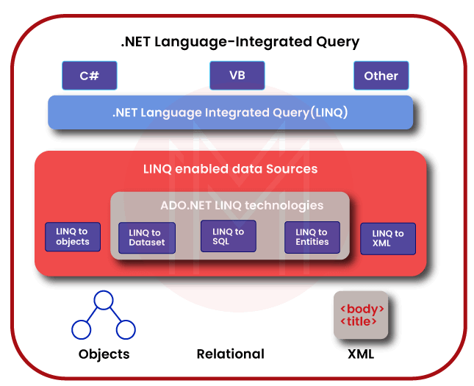

### 11. What are the differences between LINQ and Stored Procedures?

The following are the critical differences between LINQ and Stored Procedure:

1. Stored Procedure is more rapid than the LINQ query as they follow the correct execution plan.
2. It is simpler to avoid the runtime errors in the SQL query than comparing with the stored procedure.
3. LINQ utilises a .NET debugger to enable debugging, which is not in stored procedures.
4. LINQ supports multiple databases contrary to stored procedures.
5. Implementation of LINQ based solution is more agreeable than the deployment of the stored procedure.

### 12. Explain LinqDataSource Control?

If we have to utilise the LINQ in the ASP.NET web page, LinqDataSource is the essential part of the Dataset. We use it to set properties in the markup text, control, modify, and retrieve the data. We can also use it to declaratively bind the ASP.NET controls on the page to the data source. It is the same as the ObjectDataSource, and SQL Data Source controls.

### 13. What is LINQ Lambda Expression?

Lambda Expression is the function with no name. Lambda Expression makes the syntax more extensive by making it more precise and short. It is equally essential as LINQ Query even though it is not readable like LINQ Query. The scope of the Lambda Expression is restricted. We cannot reuse it.

### 14. Explain Expression Tree?

Lambda Expressions are comprehensively used in the ExpressionTree construction. The Expression Tree represents the code in the tree format, where every node is referred to as the impression. We can transform the Expression Tree into an error-free code and execute it.

In the .NET framework, we use the expression class for creating the Expression Tree using the API. The API of Expression Trees also supports assignments and control flow expressions like loops, try-catch, and conditional blocks. We can create harder Expression Trees than those created from the Lambda Expressions through the API.

### 15. What is DataContext class? Explain its relation with LINQ?

The DataContext class serves as the passing item for LINQ to the SQL framework. The DataContext class is the base for all the accesses mapped on the database connection. The DataContext is thin and inexpensive to create. After inserting the LINQ into the SQL, the blank DataContext classes that we can configure are depicted by the blank design surface.

The DataContext class stores information regarding the ways of connecting to the database. DataContext also changes the data in a database. We configure the DatContext classes with linked data that is benefited by the first item.

### 16. Describe LINQ Standard Query Operators?

The Standard Query Operators are defined as the techniques that make the LINQ pattern. We apply these techniques to the sequences where the sequence is the object that deploys the IEnumerable<T> interface or IQueryable<T> interface. Standard Query Operators offer query capabilities for the projection, aggregation, filtering, sorting, etc.

The Standard Query Operator has two groups. One group works on the **IEnumerable<T>** type objects, and other operators work on **IQueryable<T>** type objects.

### 17. Explain PLINQ?

PLINQ refers to parallel LINQ. It is the parallel execution of the LINQ to the objects. It endorses parallel(analogous) programming and is closely associated with a parallel task library. PLINQ assists with some queries to spontaneously take benefit of the multiple processors. PLINQ can increase the rapidity of the LINQ to the objects through all the existing essences on the central computer more effectively.

### 18. Differentiate N-Layer and N-Tier architecture?

N-Layer and N-Tier are two separate concepts. Generally, we use these terms while designing the application architecture. N-Tier refers to the system and essential components of our application. On the contrary, N-Layer refers to the internal architecture of our element. Following are the main advantages of the layered architecture:

* Isolation
* Abstraction
* Manageability
* Reusability
* Performance
* Testability.

Following are the benefits of the tier architecture styles:

* Scalability
* Maintainability
* Availability
* Flexibility.

### 19. What difference is between FirstOrDefault() and First() selector methods in the LINQ?

The first() method always anticipates a minimum of one element in the result set. If there is not an element in the result. First() returns the exception. Whereas **FirstOrDefault()** is compatible with the result set containing 0 elements. It will not throw any exception.

## Scenario-Based LINQ Interview Questions

### 20. Describe LINQ Compiled Queries?

In some scenarios, we may have to execute a specific query repeatedly. LINQ enables us to create the query and compile it. Following are some of the benefits of Compiled Queries:

* Compiled Queries do not require compiling every time; thus, query execution is rapid.
* Compiled Queries are compiled once, and we can use them any number of times.
* Compiled Queries must be recompiled even though the query parameter is being modified.

**Example**

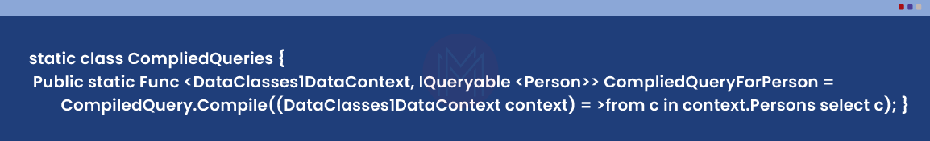

### 21. Explain Anonymous Types?

The Anonymous types are defined as the run-time compiler created by the compiler. We don’t need to define a name for creating an Anonymous compiler, but we can define the properties' names and allocate values to them dynamically.

var v = new { PropertyFirst1 = ‘first value1’, PropertySecond1 = ‘second value1’};

Console.WriteLine(k.PropertyFirst1);

Anonymous class is useful in LINQ queries. It stores the intermediate results while doing the queries:

* Anonymous types will not implement interfaces.
* Anonymous cannot define the methods.
* We cannot specify the static numbers.
* We should initialise all the specified properties.
* We can only specify the public fields.

### 22. Describe why the SELECT clause comes after FROM clause in the LINQ?

LINQ needs all the queries to be defined first. The “FROM” clause of the LINQ query specifies the range or condition for selecting the records. Thus, the “FROM” clause should act before “SELECT” in the LINQ query.

### 23. Explain LINQ providers in LINQ?

LINQ Providers are the group of classes that take the LINQ Query, which creates a method that implements the equivalent query against a specific data source.

### 24. What are SelectMany() and Select() in LINQ?

In the LINQ SelectMany() and Select() are the projection operators. We use the Select() operator for selecting a value from the collection, while the utilisation of the SelectMany() operator is for selecting the values from the group of a collection, i.e. the nested collection.

### 25. Explain Entity Classes?

In LINQ, Entity Classes are the basic building blocks of the system. They act as the object wrapper for the database table. It contains the stereotype of the entity.

### 26. What are the Quantifier Operators?

In LINQ, Quantifier Operators are those that return the boolean value, i.e. False or True. Following are the different kinds of Quantifier Operators:

* Any()
* All()
* Contains().

### 27. What are the advantages of Deferred Execution?

Deferred Execution evaluates the delayed expression till its realised value is required. It can considerably enhance the presentation when we need to affect vast data collections, particularly in the programs that encircle the series of chained queries.

### 28. What is an object-relational designer?

An object-relational designer offers a visual design surface for making the LINQ to SQL relations and entity class according to the objects in the database.

### 29. On what parameter does the GROUP BY clause group data?

The GROUP BY clause groups the basics that share the common attribute.

### 30. Which extension method do we require to execute the parallel query in PLINQ?

The “AsParallel” extension process is needed for running the query in the PLINQ.

### 31. What is the purpose of System.XML.Xlinq.dll?

System.XML.Xlinq.dll offers the functionality for working with the LINQ to SQL.

### 32. Differentiate Expression Lambda and Statement Lambda?

We extensively use Expression Lambdas for the construction of the Expression Trees. We cannot use the statement Lambdas for creating the Expression Trees.

### 33. Differentiate “ToDictionary” and “IEnumerable”?

* ToDictionary is the instance of the Directory(K, T). The “keySelector” predicate recognises the key of every item, whereas we use “elementSelector” for extracting every single item if it is provided.
* The extension method of “IEnumerable” is “AsEnumerable.” The “**AsEnumerable**” returns the source sequence as the object of “IEnumerable.”

### 34. What are SkipWhile() and Skip() extension methods?

**Skip()**: It takes the integer argument from the provided IEnumerable and skips the top n numbers.

**SkipWhile()**: It continues to skip the elements until the input condition is true. It returns all remaining elements if a condition is false.

### 35. Define the “Let” Clause?

In the Query Expression, we use the **“Let”** clause for storing the result of the sub-expression for using it in the consequent clauses. We can do this through the “Let” keyword, which produces a new range of variables and initialises with a result of the expression we supply.

### 36. Differentiate Take(1) and First()?

The difference between Take(1) and First() is that Take() returns the sequence of the elements that comprise only one element, whereas First() returns the element.

### 37. Explain the “WHERE” clause?

“WHERE” clause enables adding conditional filters to the query.

### 38. What are the benefits of using the LINQ Dataset?

Following are the benefits of utilising the LINQ Dataset:

* We can execute the strongly typed queries on the datasets through LINQ.
* If we want to integrate the values of the datasets or extract the unique value from the dataset, LINQ will be helpful.
* Through LINQ, we can query the dataset more efficiently with the latest features in comparison to ADO.NET.

### 39. Explain Anonymous Functions?

The anonymous function is defined as the function without any name. We only specify the parameters in the anonymous function and build the code in curly braces.

## LINQ Interview Questions For Experienced

### 40. Define Action?

Action is defined as the common delegates associated with the base class library of .NET. We can save only the methods with input parameters and void return types in Action. We can specify up to 16 parameters.

### 41. Explain Predicate Delegate?

Predicate Delegate is offered by the basic class of the .NET library. In the Predicate, we are enabled to save only the methods with the one input parameter and the bool return type. Predicate delegates are helpful in the scenarios where the filter is required.

### 42. Name Command-Line that creates the code and mapping for LINQ to SQL component of the .NET framework?

“SqlMetal.exe” is the command-line tool that creates the code and maps LINQ to the SQL element.

### 43.  What is LINQ to XML?

LINQ to XML offers integral document modification abilities of DOM and supports the LINQ queries. Through it, we can amend the query and store the modifications of the XML document. It allows us to develop the queries and recover and lead a compilation of the attributes and elements.

### 44. Explain “LINQ to Objects”?

When the LINQ queries any IEnumerable or IEnumerable() collection without utilising the intermediary LINQ provider or the API like LINQ to XML or the LINQ to SQL is known as the LINQ to objects.

### 45. Differentiate the Take and Skip clause?

We use the “Take” clause for returning only a certain number of elements. While the “Skip” clause hops a certain number of elements and returns the remaining elements.

### 46. What are Sequence and Query Operators in LINQ?

The sequence is defined as the collection class we have to query. The element is the single item in the collection class, and the class should implement the IEnumerable interface.  Query Operators comprehend the sequence as the input, implement it and return the latest result sequence.

### 47. LINQ query is implemented in which statement?

In VB, the LINQ query is implemented in the **“For Each”** statement and in the **“foreach”** statement for the C#.

### 48. Explain Extension Methods?

The extension methods are the static functions of the static class. We can invoke these methods the same as the syntax of the instance method. We can use these methods when we don’t need to modify the class.

### 49. How can we find an index of elements through Where() with Lambda Expression in LINQ?

For finding an index of the element through the overloaded version of the Where() with Lambda Expression:

Where((j, jx) => j = = jx);

### 50. What is the difference between utilising the LINQ to SQL and Entity Framework as the ORM?

* LINQ to Entities is the ORM API that allows a wide definition of the object domain models and relationships to various ADO.Net data providers. By definition, we can combine and match various database vendors, application protocols or servers for designing the aggregated mash-up of the objects built from different services, tables, sources, etc.
* LINQ to SQL supports only 1 to 1 mapping of the database views, tables, functions, and sprocs available in the Microsoft SQL Server. It is the best API for rapid data access production to comparatively well-developed SQL Server databases. LINQ2SQL was launched with .NET Framework 3.5 and C#3.0.

### 51. Explain Query Syntax?

Query Syntax is the same as the Structured Query language to the database. It is enclosed within VB or C# code.

**Syntax:**

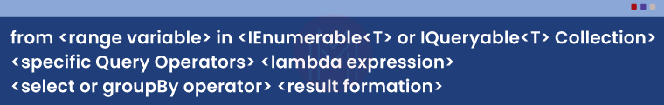

Following are some essential topics of Query Syntax:

* It begins with the “FROM” keyword and finishes with the “GROUP BY” or “SELECT” keyword.
* It is similar to the SQL syntax.
* It utilises different operators like grouping, joining, filtering, and sorting for constructing the required result.
* It utilises implicitly typed variables for storing results of LINQ Query.

### 52. Describe LINQ method syntax?

LINQ method syntax or fluent syntax utilises other methods covered in Enumerable or Queryable static class.

* Method syntax is similar to invoking the extension method.
* LINQ Method Syntax is also called fluent syntax as it assists a group of extension methods to call.
* We can use an Implicitly typed variable for storing the results of the LINQ Query.

**Syntax**:

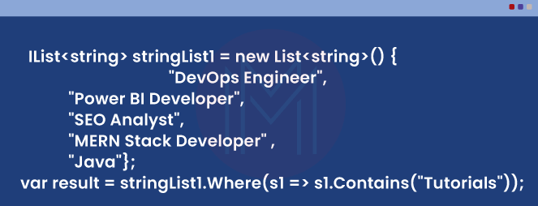

### 53. How will you count the elements of a collection or a list?

We use **Count()**function for counting the number of the items in the list.

**Syntax**

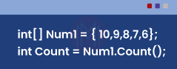

In VB.net

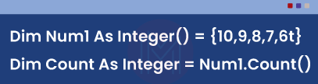

### 54. What is the fundamental syntax of the LINQ Query in the Visual Basic and C#?

In the Visual Basic, we use the “From” keyword for starting the LINQ Query’s fundamental syntax, and it finishes with GROUP By or Select Keyword. We can use other keywords like Order By, where, Order By Descending, etc., to perform additional functions like creating or filtering data in a particular order.

In the C#, the fundamental syntax begins with the “From” keyword and “ends” with GROUP BY or Select keyword. We can also use other clauses like Order By, Where, Order By Descending, etc., to carry out other tasks like creating or filtering data in a particular order.

### 55. How can we allocate the Lambda Expression to a delegate?

For allocating the Lambda Expression to a delegate:

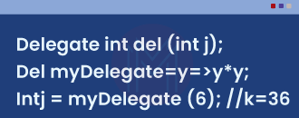

### 56. What is the use of standard query operators in LINQ?

We use Standard Query Operators to

1. Retrieve the total count of elements in a collection.
2. Order the results of the collection.
3. Calculate Average
4. Grouping
5. Filter results
6. Joining the two collections according to the matching keys.

### 57. How can we retrieve the single row with LINQ?

For retrieving the single row with the LINQ, we require

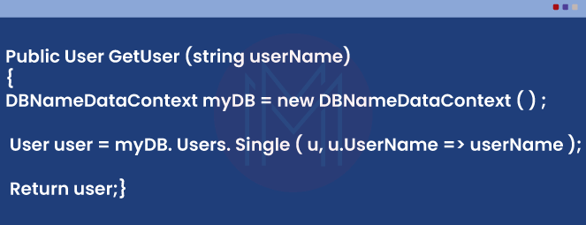

### 58. How can we use LINQ with the databases?

LINQ supports SQL, XML, Objects, and Datasets. Using the LINQ to Datasets or LINQ to objects, we can utilise the LINQ with other databases. The datasets and Objects look after the database operations, and LINQ only requires to handle with those objects and not database operations.